Setting up the Dial Judging System in 10 steps

1. Download the Dial Judging software [here](https://github.com/SmilesAir/DialJudger/raw/eb266d7c03af1a004f77659a037c23281d262caa/DialJudgeBins.zip).
   * Optional – Full source on GitHub: <https://github.com/SmilesAir/DialJudger>
2. Unzip into a folder on your computer. You should see something like this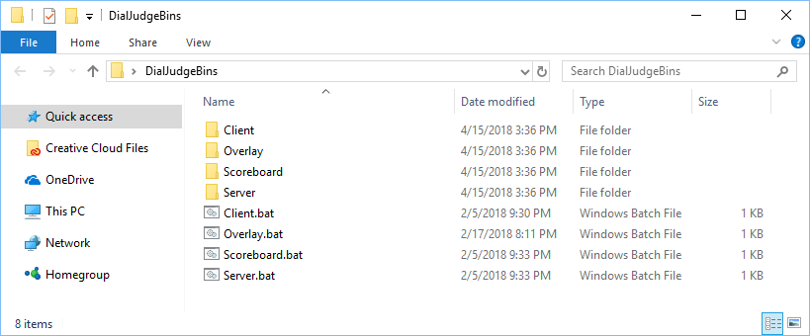
   * The 4 .bat files at the bottom are shortcuts to start each program. If those don’t work, you can manually browse to the .exe in the folders.
3. Run the Server.bat. It may take a minute to startup the first time.
   * Allow it pass through the firewall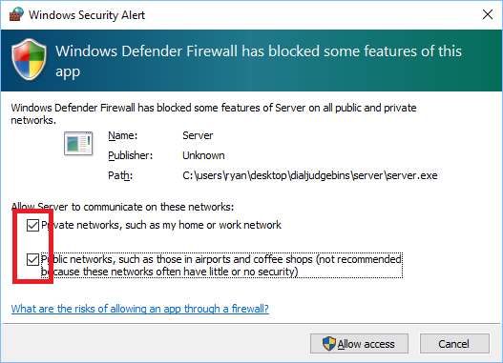
4. Enter the teams and judges and press the import buttons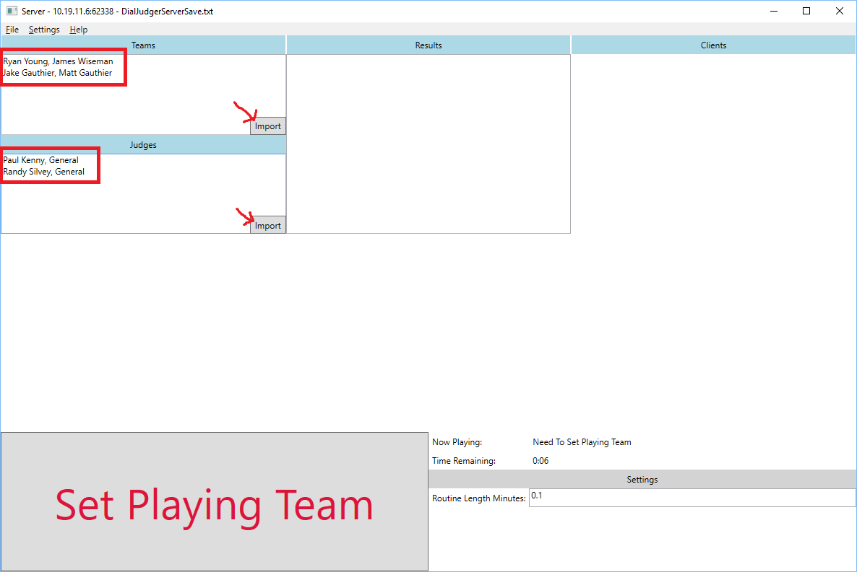
5. Click Set Playing on the first team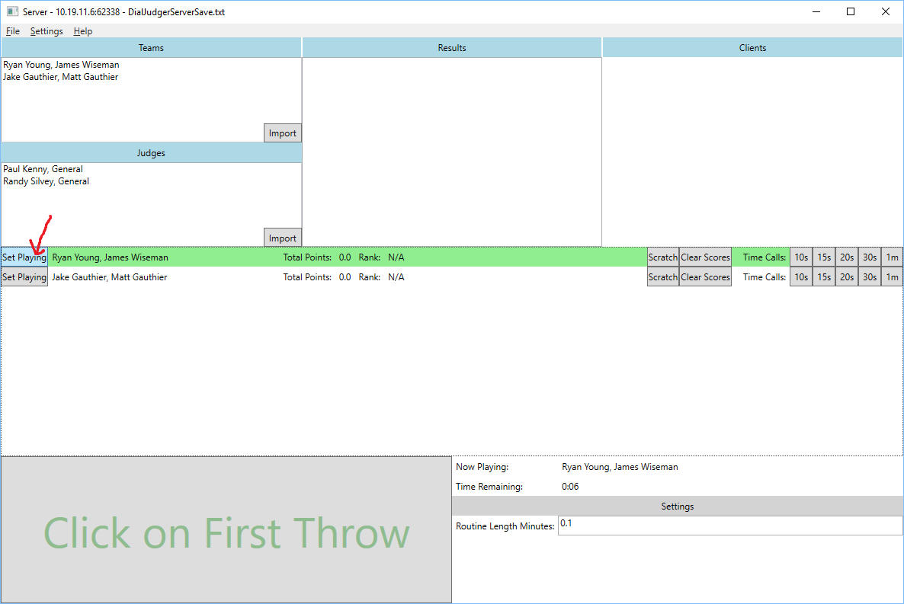
6. Set the routine length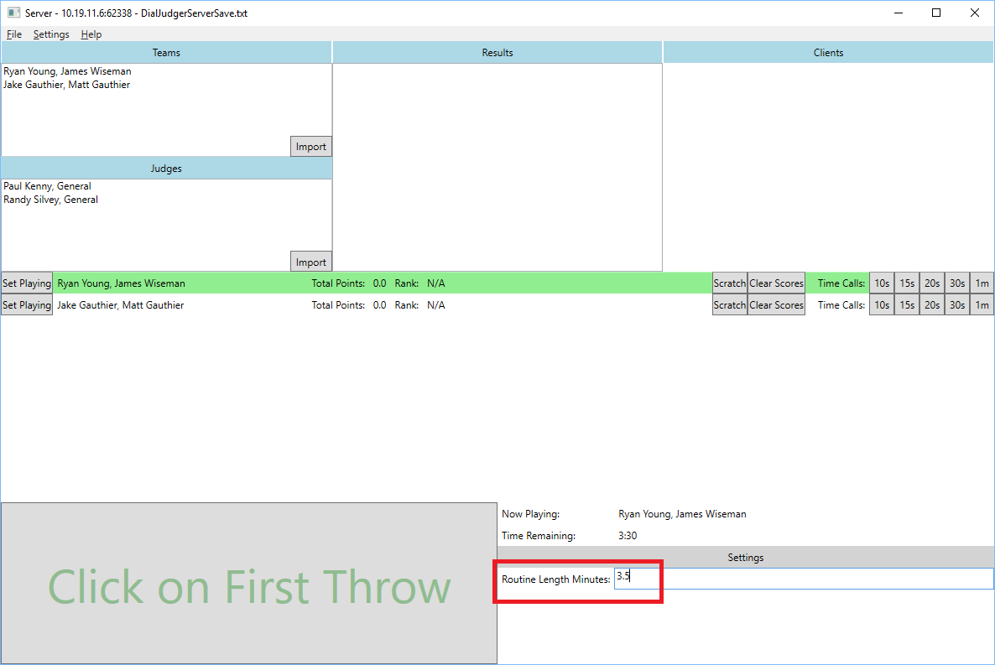
7. Run Client.bat from the folder where you unzipped the files. It may take a minute for the program to open the first time.
   * **You can run multiple Clients on the same computer. You can also run additional Clients on computers on the same LAN**
   * Allow the Client through the firewall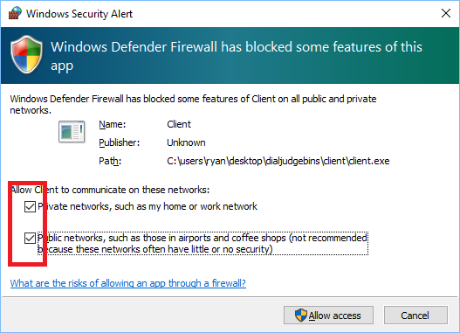
8. You should see a window like this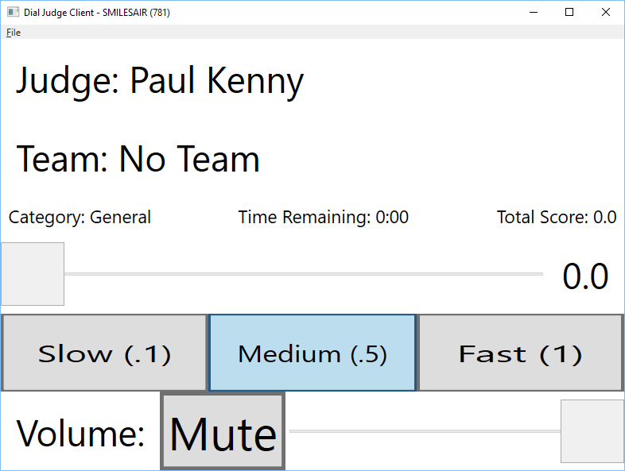
   * You can drag the slider to adjust the score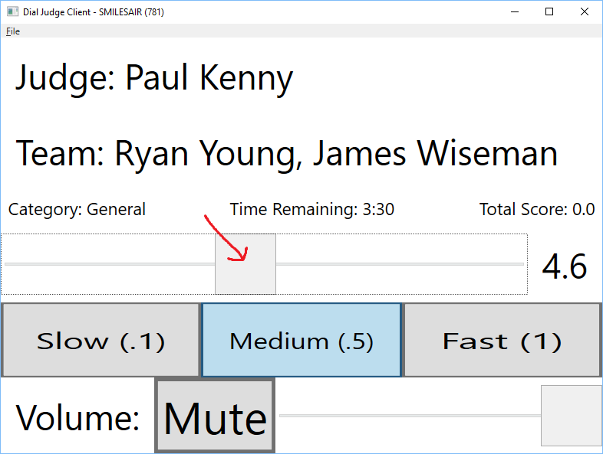
9. On the Server window, press the Click of First Throw button to start judging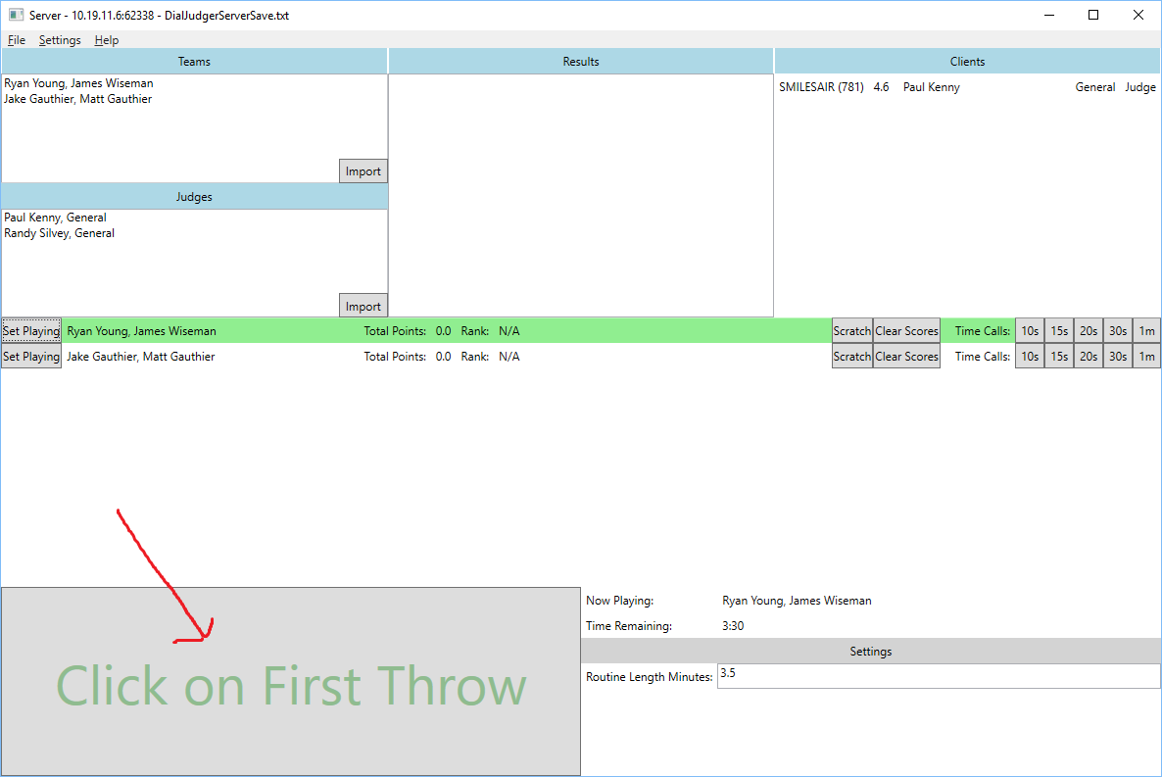
10. Once the routine finishes. Press Set Next Team to get ready for the next team